VR_ON motherboard repairing ka sabse important signal hai, kyunki ye CPU ko "ab start ho jao" ka permission signal deta hai.

VR_ON = Voltage Regulator ON
Simple definition:
VR_ON ek Active High signal hai jo CPU/GPU ke VRM Controller ko ON karta hai.
Matlab:
"Ab CPU ke liye VCORE generate karo."
CPU Core ko chalane wali supply VCORE hoti hai, jo VR_ON ke baad VRM Controller generate karta hai.
Ye kis se aata hai?
Platform ke hisaab se alag ho sakta hai.
- Purane Intel boards → PCH
- Intel SoC → SoC/PMU
- AMD → SMU/PMU
Lekin 90% cases me VR_ON ka owner SoC/PCH hota hai.
Sequence me VR_ON kab aata hai?
19V
↓
3VALW / 5VALW
↓
1.0VALW
↓
Power Button
↓
RSMRST#
↓
SUSCLK
↓
SLP_S5#
↓
SLP_S4#
↓
SLP_S3#
↓
⭐⭐ VR_ON ⭐⭐
↓
CPU VCORE
↓
CPU Execute BIOS

⭐ Repair Memory Trick

ALW Voltages
│
▼
Power Button
│
▼
SLP Signals
│
▼
⭐⭐ VR_ON ⭐⭐
│
▼
VRM Starts
│
▼
CPU VCORE
│
▼
BIOS Execution

VR_ON ka Voltage
Normally:
0V = OFF
3.3V = ON
Kuch boards me:
1.8V = ON
Ye platform par depend karta hai.

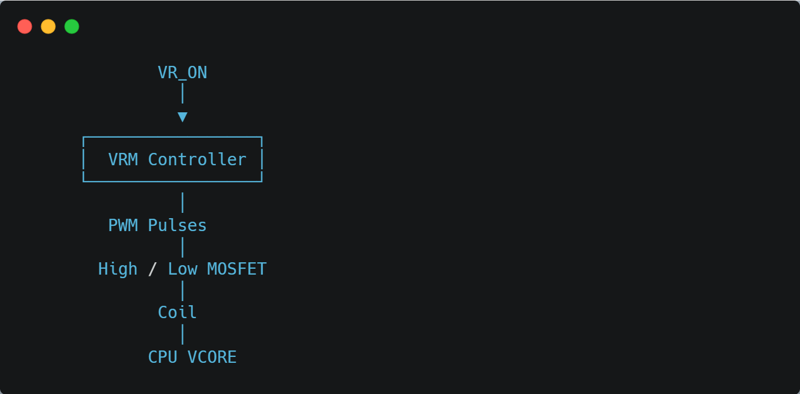

Schematic me Kaise Search Kare?
Search keywords:

VR_ON

CPU_VR_ON

IMVP_EN

VCCCORE_EN

VCORE_EN

Technician Rule
Agar motherboard me
✔ Power aa rahi hai
✔ SLP Signals aa gaye
Lekin
❌ CPU VCORE nahi hai
To sabse pehle check karo:
- VR_ON
- VRM Controller ka VIN
- VRM Controller ka VCC
- VRM Controller ka EN
- MOSFET
- Coil

